Kartikey Attri
8025320046
ME-CSE
Group-2
PCS223 Advanced Computer Networks

1. To capture and analyze ICMP packets (Ping request and reply)

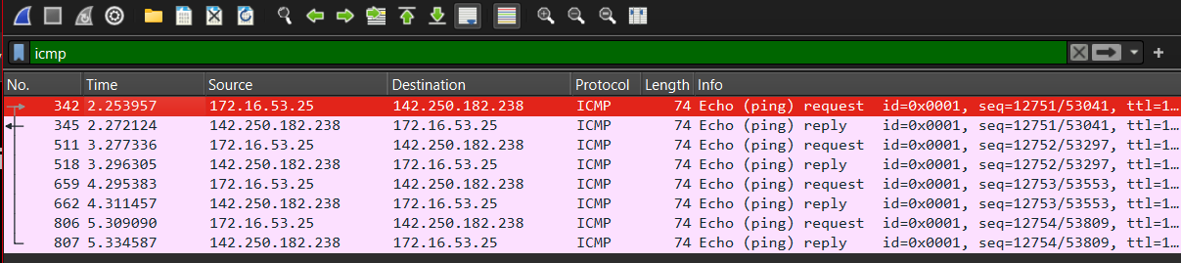
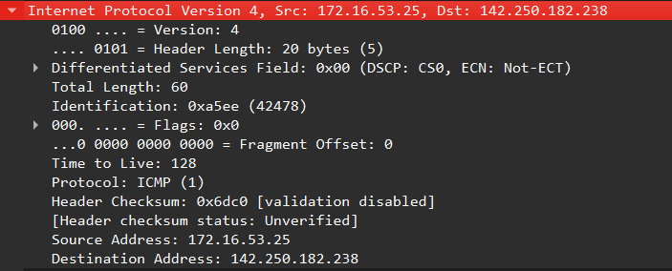
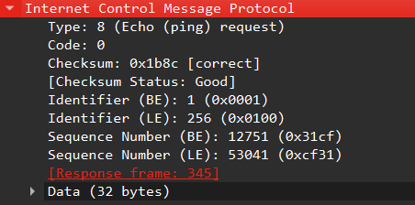

2. To analyze TCP packets and observe the TCP three-way handshake
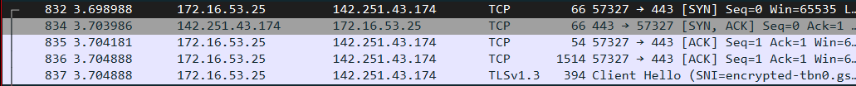
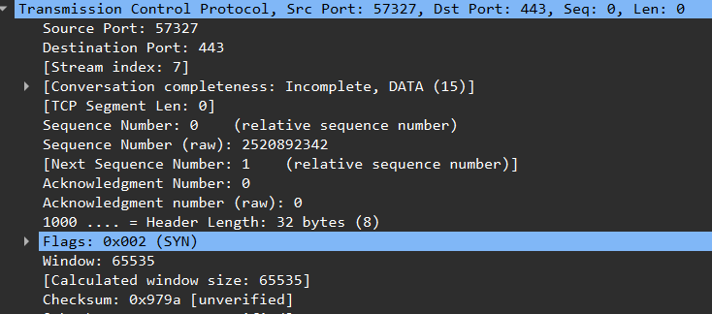
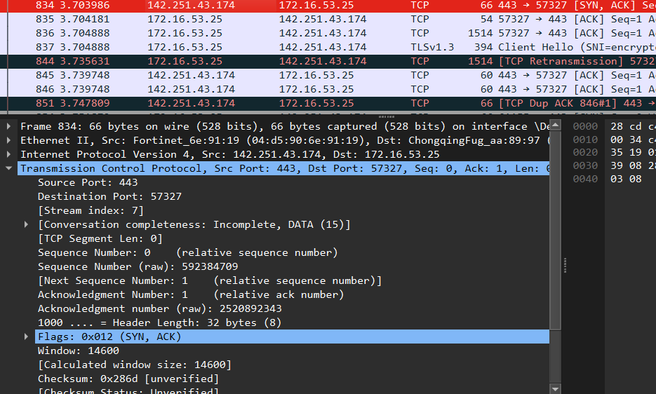
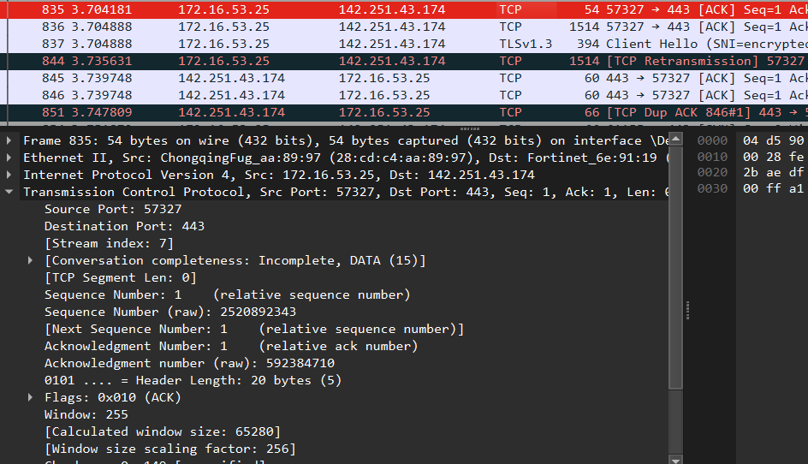

3. To capture and analyze UDP packets
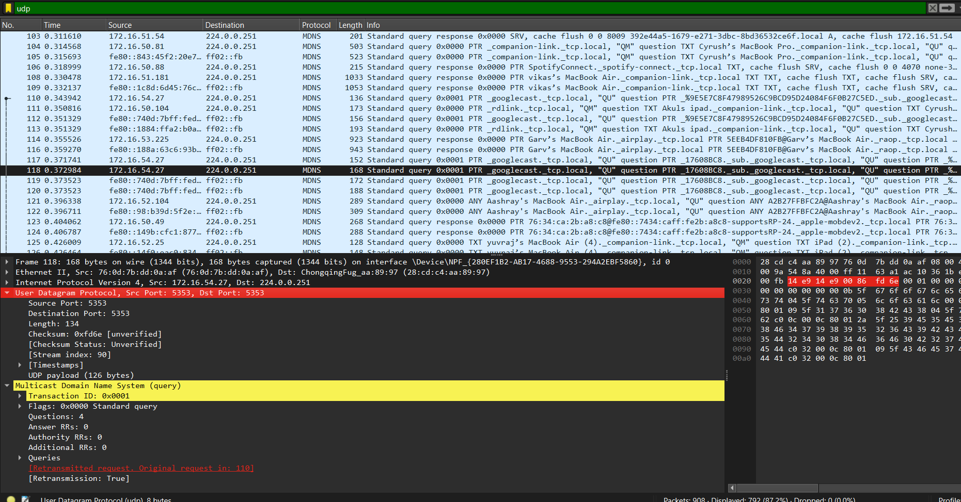

4. To capture and analyze DNS query and response packets
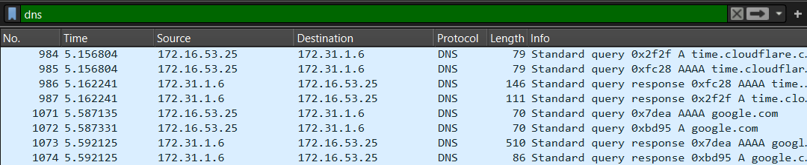
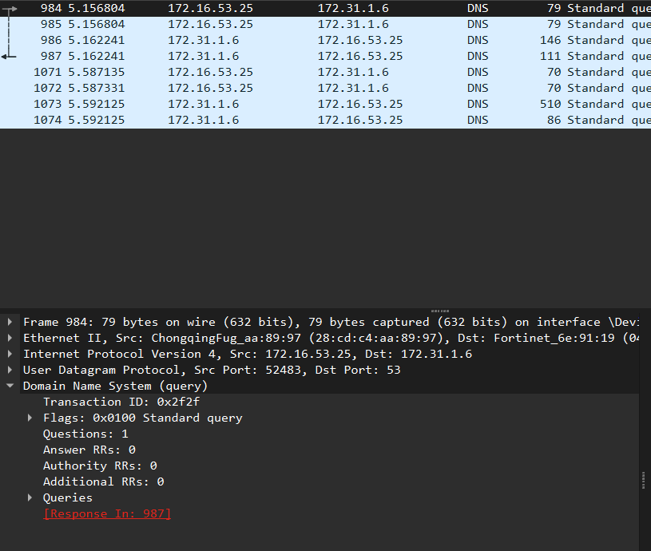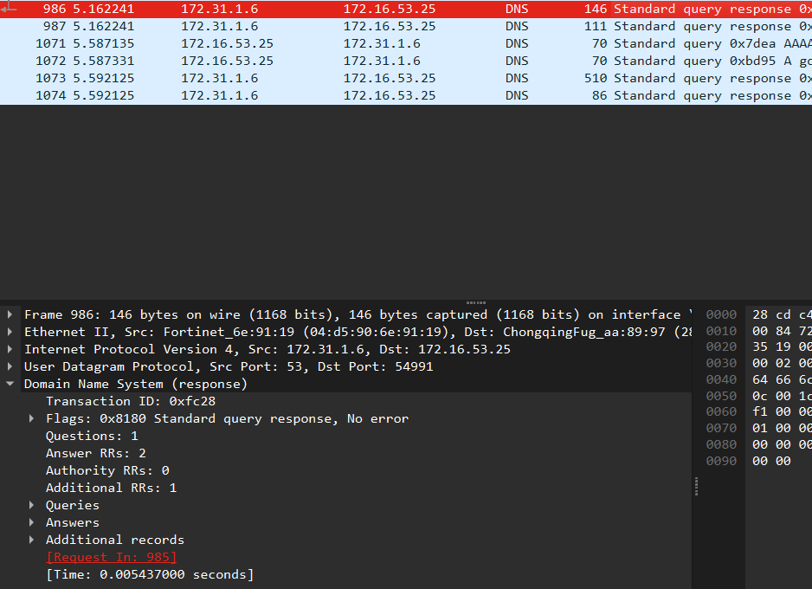

5. To capture and analyze HTTP packets
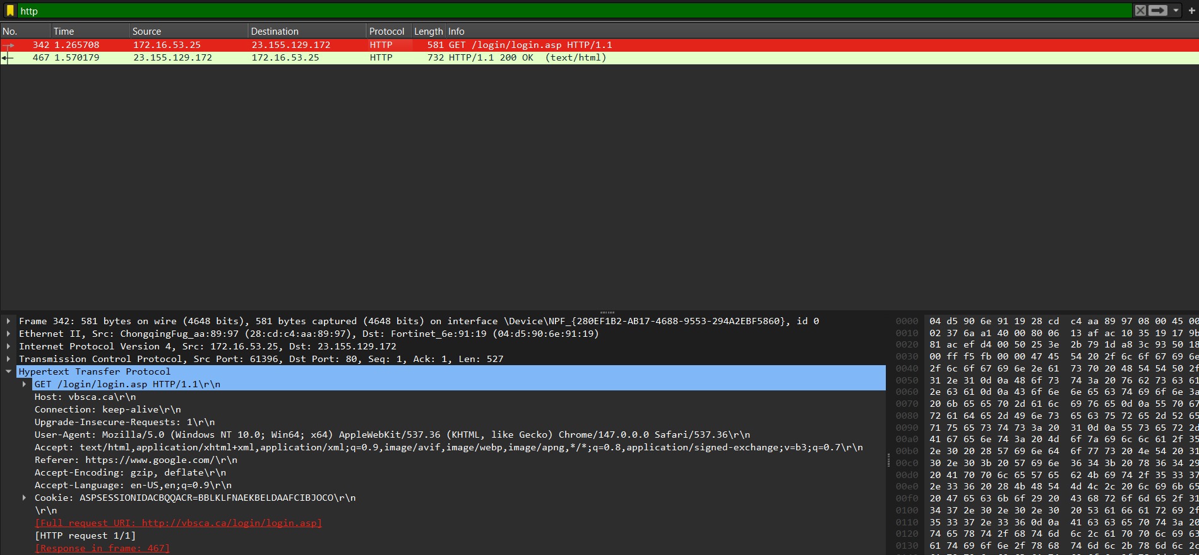
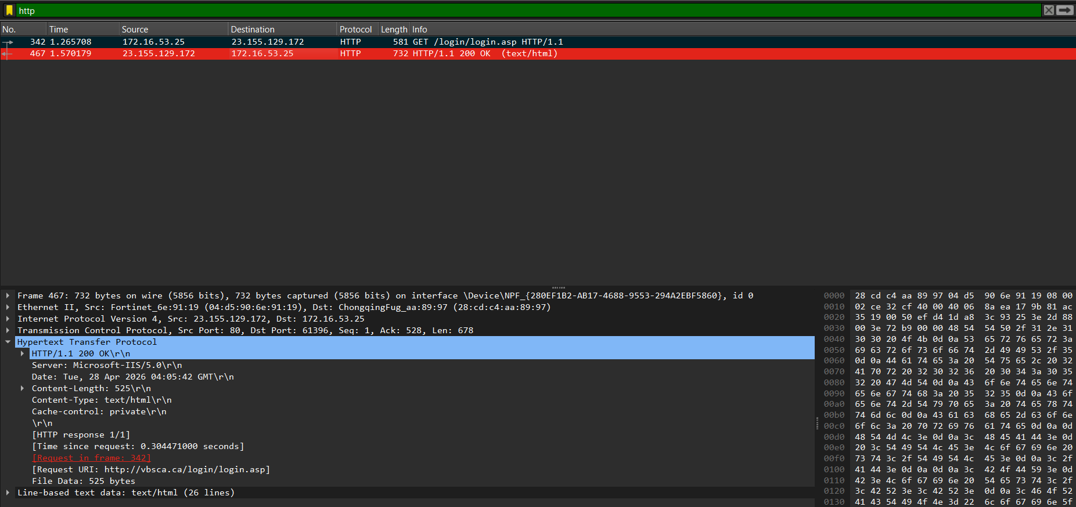

6. To analyze ARP request and reply packets
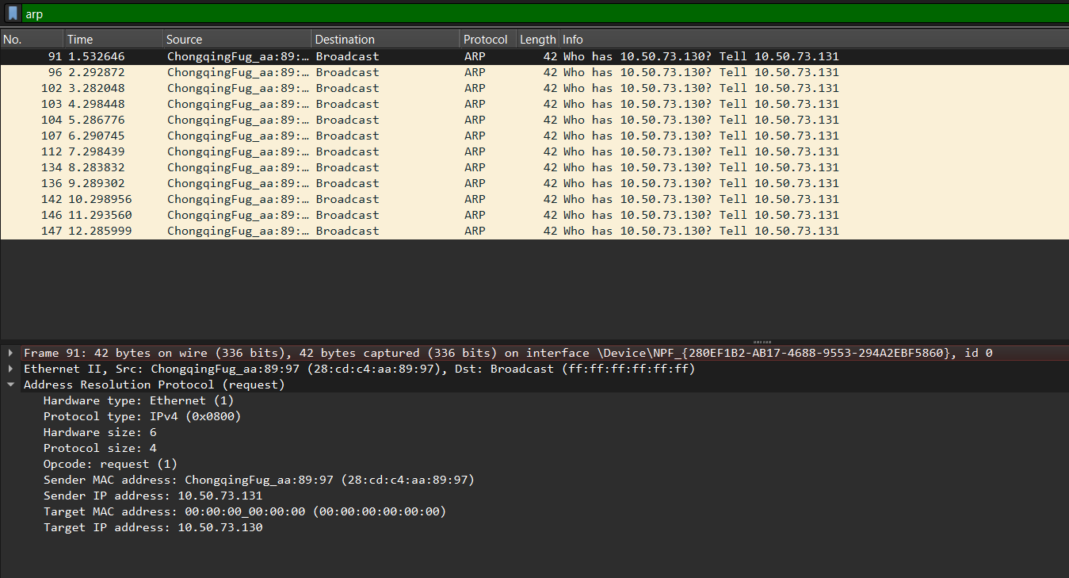

7. To identify source and destination MAC and IP addresses in captured Packets
